**How to watch Australian open 800 S4**

**Introduction**

Tennis is a popular sport viewed and liked by millions across the world. Often called the game of the rich, it is now one of the most enjoyed sports around the globe. There are a lot of tennis tournaments around the world. But four events are considered the big 4 among all these. The Australian Open, US Open, French Open, and Wimbledon are the four big competitions combined known as the Grand Slams. For these titles, which are an honor to win, many players from different parts of the world participate. The US Open, a two-week tournament held on hard courts, is usually played in late August or early September. The Australian Open, played on hard courts, lasts two weeks in mid-January. The French Open is a two-week event played on a red-clay court in late May or early June. Wimbledon is played on grass courts and lasts for two weeks in late June or early July.

**How to watch The Australian Open:**

**Such features, fame, and quality of The Australian Open have made it one of the most popular tournaments in the world and has millions of viewers around the world annually. To be precise it has the record for the greatest number of people who watched a Grand slam at 812000 people attending it in 2020. Currently, The ESPN broadcasting network owns the broadcast rights of this prestigious event. People from UK and Europe can enjoy the Australian Open 2022 on Eurosport. The Eurosport app, Discovery+, and Eurosport.com will broadcast the games live. The Australian Open tennis event is available to watch on ESPN and ESPN2, with the title matches televised live on ESPN. ESPN's internet streaming service, ESPN+ (or ESPN Plus), will provide a live broadcast of the 2022 Australian Open. You can watch the games live on your phone, laptop, tablet, or TV with an ESPN+ membership. Additionally, you'll have access to the entire ESPN+ on-demand library.**

**The Disney+ Bundle, which includes more channels such as ESPN+, Hulu, and Disney+ for merely $13.99 per month, is your best option even if ESPN+ costs $7.99 per month here.**

**The Australian Open:**

The Australian Open happens in Australia for two weeks around mid-January. Every year, it takes place in Melbourne, Australia's renowned Melbourne Park. The happy slam is another name for the Australian Open. It is named that way since the locals there treat the tournament like a festival, drawing sizable crowds to the games and treating them as a big festival. Also, the perfect weather and climate over there make it a wonderful place to sit back and enjoy a good game of tennis of this grandeur. The Australian Open has quite a few special features which make the tournament one of the biggest in the Southern Hemisphere. Australian Open is the first Grand slam tournament to have the facilities such as retractable roofs and provides the feature of indoor play in situations where rain or highly wet or hot climatic conditions affect the matches played in the stadium. The tournament consists of five categories namely Men’s singles in which men will compete against each other in a straight dual, Men’s doubles in which two men in each team compete against other teams or doubles, Women’s singles in which each woman will compete against another single woman in a straight match-up, Women’s doubles where a team of two women competes against other teams or doubles, Mixed doubles where a man and a woman in a team competes against other similar teams or doubles. All the games are knock-out games.

**Current champions:**

Currently, Rafael Nadal won the Men’s singles title, which is his 21st major grand slam title and his second Australian Open title. He is fondly known as the ‘King of Clay’ due to his dominance in French Open where he had won a record 14 titles. Ashleigh Bartley won her maiden Women's Singles title of the Australian Open. The Men's Doubles title was won by Thanasi Kokinakis and Nick Kyrgios. The Women's doubles championship was won by Barbora Krejčíková and Kateřina Siniaková. The Mixed Doubles championship was won by Kristina Mladenovic and Ivan Dodig. Serbia’s star tennis player Novak Djokovic holds the record of having the highest number of Australian Open titles. He has won the coveted title a record 9 times in the Men’s singles category. Serena Williams, the US national Tennis star has won the Australian Open title a record 7 times in the Women’s singles category which makes her the player having the greatest number of titles in the women's category.

**Conclusion:**

Are you trying to find a way to watch the Australian Open for free online? Don’t worry, there are a few online websites that broadcast the matches for free. To watch the games, use either the free trials for Sling TV or FuboTV websites. Some of the tennis fan groups on social media share it live for the fans in their social groups. Overall, the buzz for the Australian Open is well and truly alive and this year’s competition will be a cracker for the fans.

**FAQ:**

**1) How to watch the Australian Open in India?**

People from India can watch and enjoy the Australian open on Sony six channel. Sony has the broadcasting rights to the Australian Open in India.

**2) How to watch Australian open online in India?**

Sony Liv and JioTV broadcast the Australian Open live online in India.

**3) Is Australian open the biggest tournament in Tennis?**

Australia open belongs to 1 of the 4 Grand slam events but Wimbledon is the most prestigious event in Tennis.

**Spinmenot screenshot:**

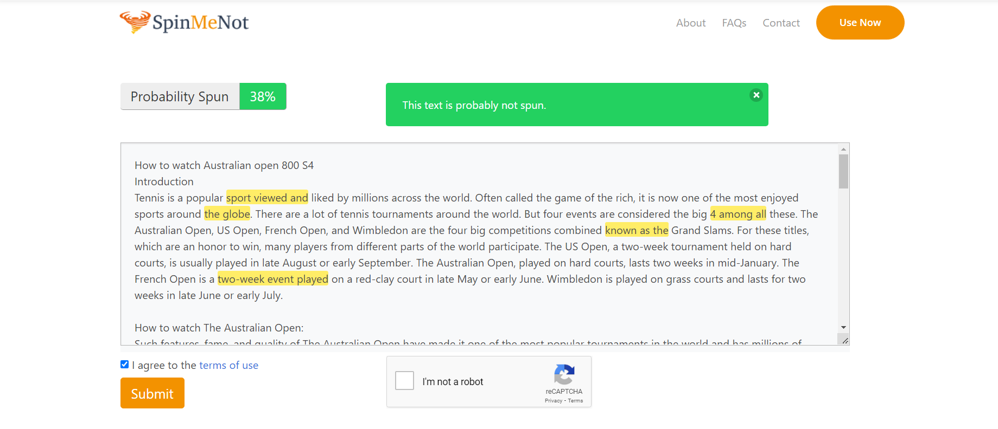

**Grammarly screenshot:**

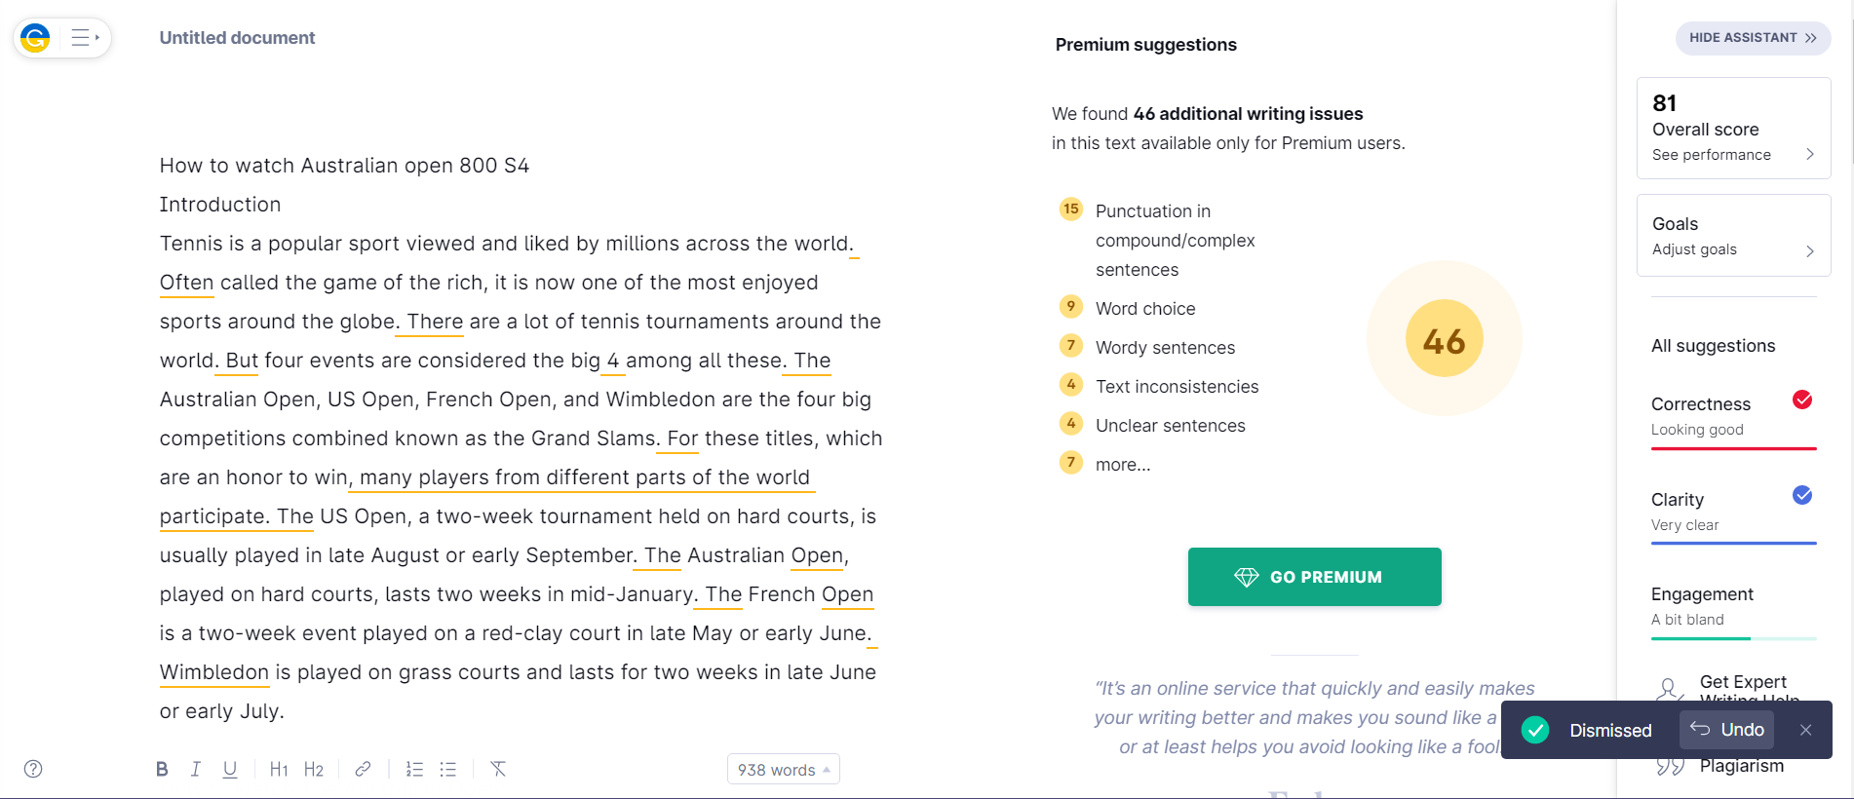

**Quetext screenshot:**

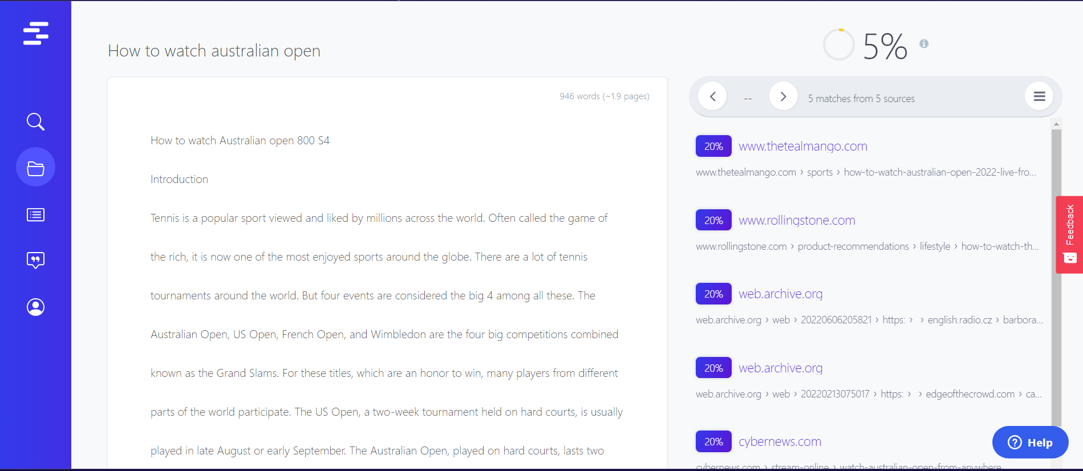

* **Article by Sanjay M**